CKA-Chapter1- Syllabus

Kubernetes, also known as K8s, is an open-source system for automating the deployment, scaling, and management of containerized applications. This container management system’s popularity soared with the rise of businesses operating on cloud infrastructure and technology.

Having knowledge about Kubernetes gives you a more holistic view of the entire software lifecycle. Particularly in larger organizations, development is usually seen as writing, reviewing, and merging code, after which a CI pipeline comes along and “deploys” it.

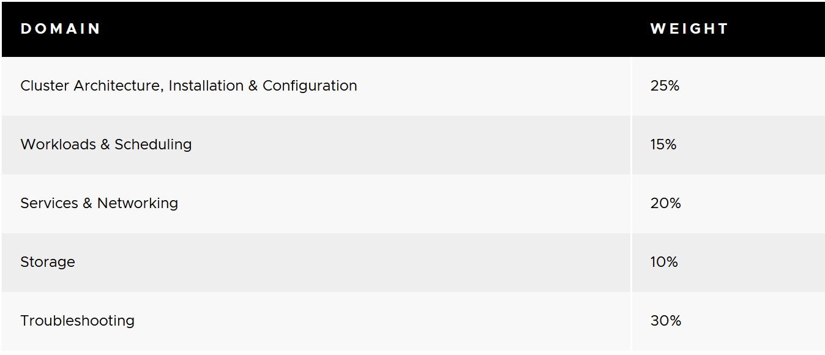

CKA-Chapter2- Why Kubernetes?

Our primary goal is converting monolithic application to microservice application.









CKA-Chapter3- Kubernetes Architecture

Kubernetes architecture, also sometimes called Kubernetes application deployment architecture or Kubernetes client-server architecture, is used to compose, scale, deploy, and manage application containers across host clusters.

The control plane's components make global decisions about the cluster (for example, scheduling), as well as detecting and responding to cluster events (for example, starting up a new pod when a deployment's replicas field is unsatisfied). Control plane components can be run on any machine in the cluster.

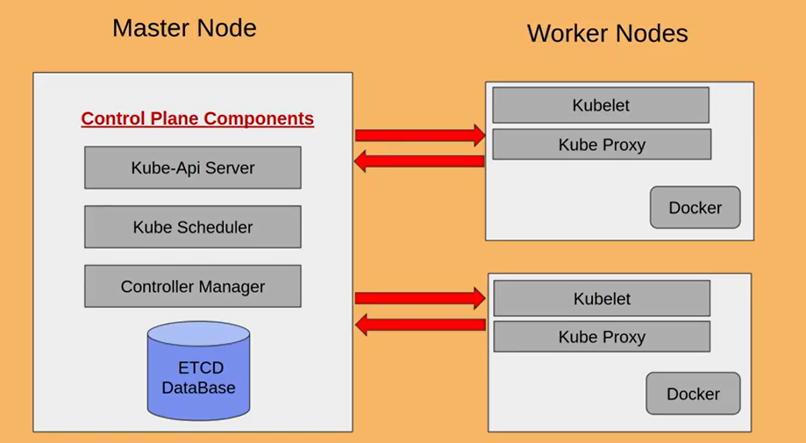

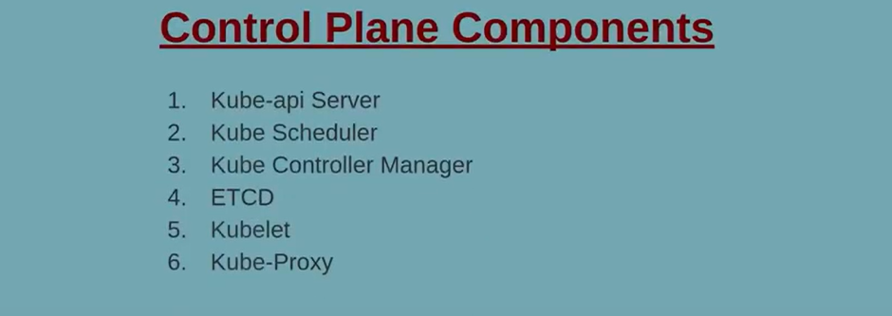

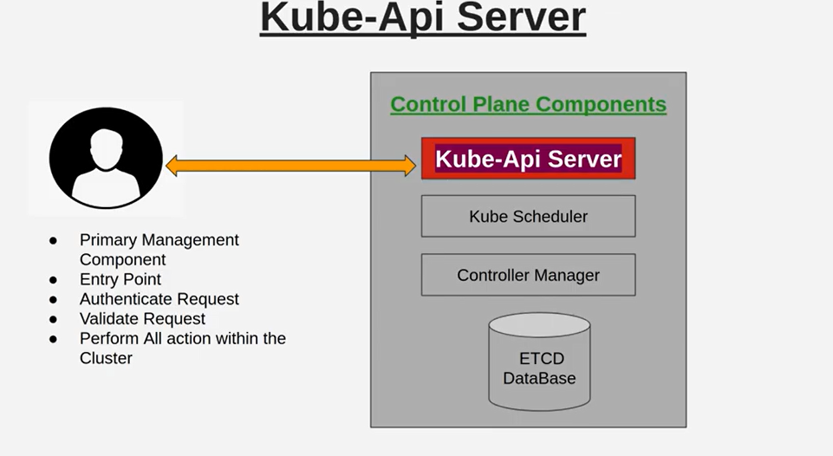

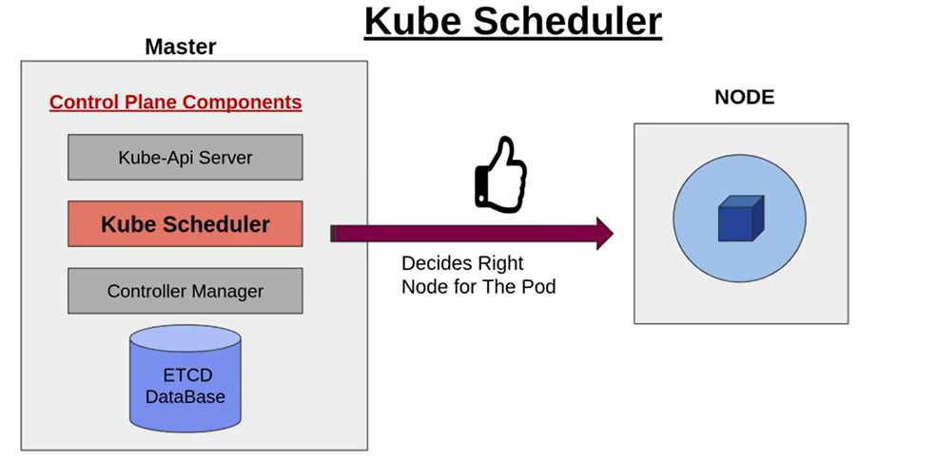

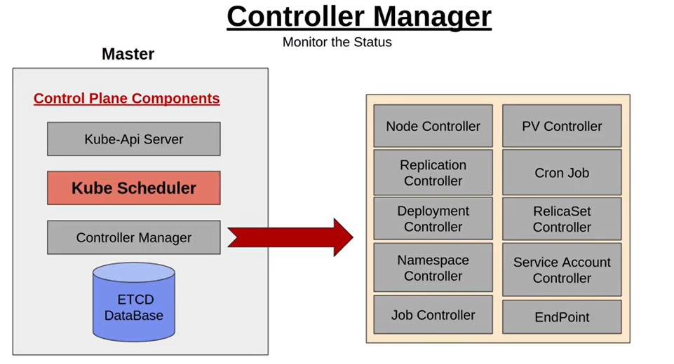

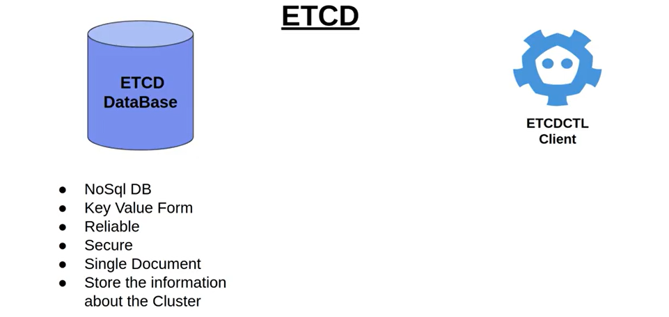

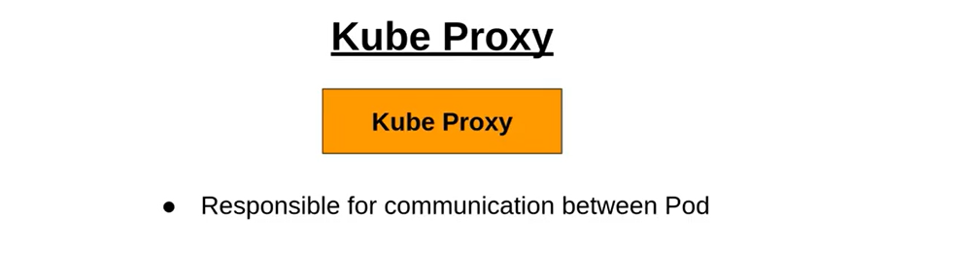

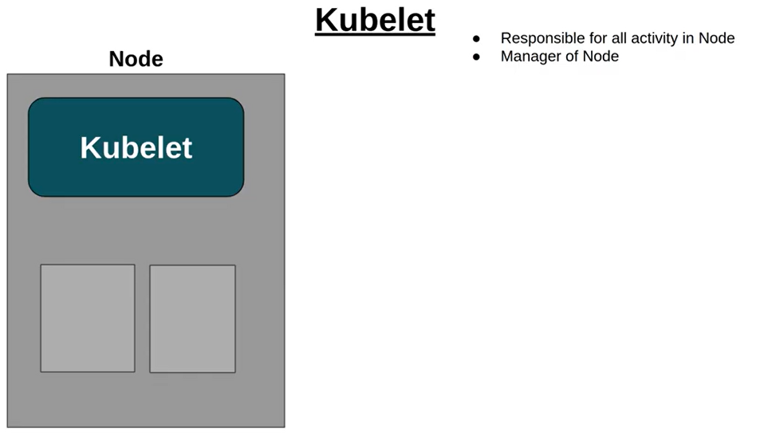

How pods are getting created?



Step1) User will request to API server to create pod, and API server create blue-print of pod.

Step2) API server communicate to scheduler, and find right node for it.

Step3) Once right node is identified then scheduler will communicate to kube-agent, and node would be created.

Step4) Once Pod is created then this information would be updated in ETCD cluser.

CKA-Chapter4- Tool to support high availability server

Before, we start we should be clear with two things-

1. Why we need to setup cluster
2. Where we need to create cluster(on prem/cloud)

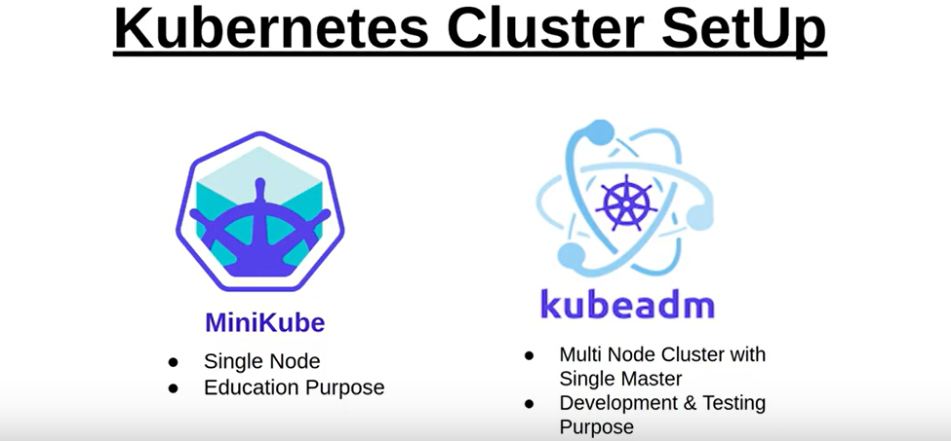

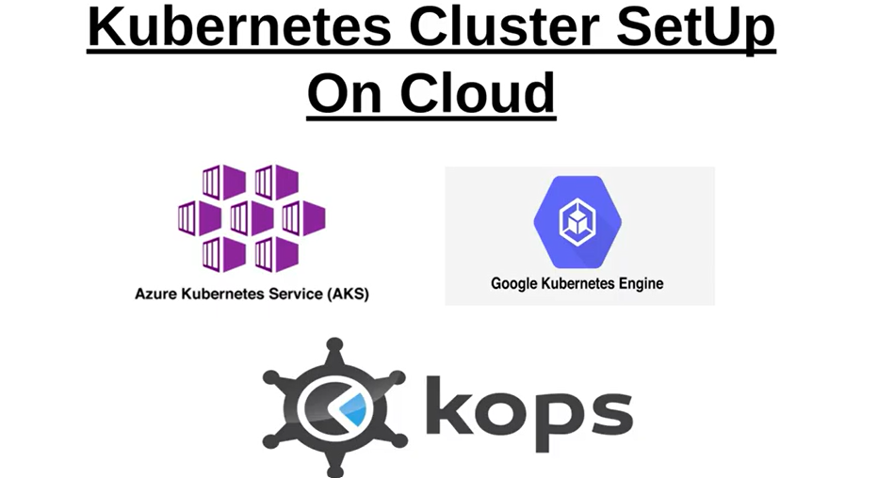

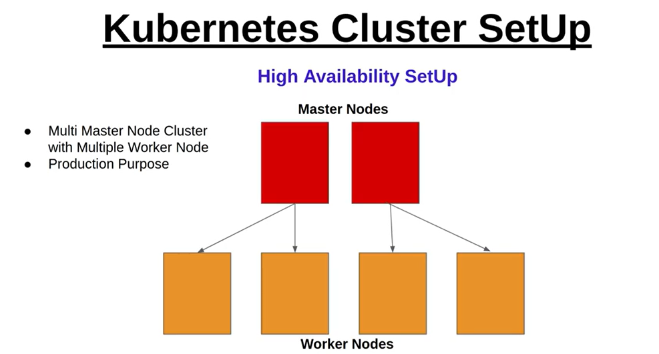

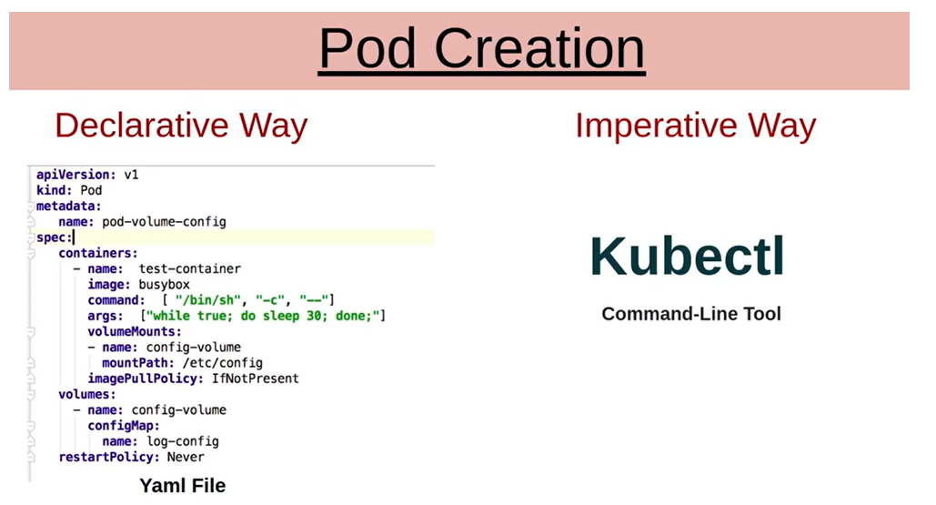

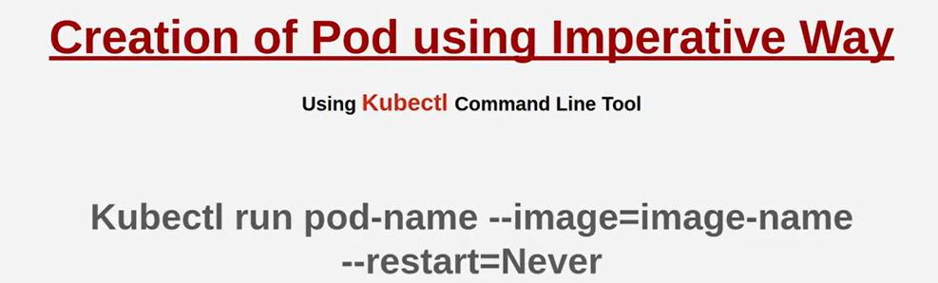

Exacize:

1) Create a pod with nginx image.

2) Replace nginx image with tomcat image.

3) Check Application status.

4) Create a pod with level

5) Create a pod with annotation

6) Delete the pod.

[Note]: Do with both declarative and imperative way.

CKA-Chapter5- Replicase and Replication controller.

✳️ ReplicaSet A ReplicaSet's purpose is to maintain a stable set of replica Pods running at any given time. As such, it is often used to guarantee the availability of a specified number of identical Pods.

✳️ ReplicationController A ReplicationController ensures that a specified number of pod replicas are running at any one time. In other words, a ReplicationController makes sure that a pod or a homogeneous set of pods is always up and available.

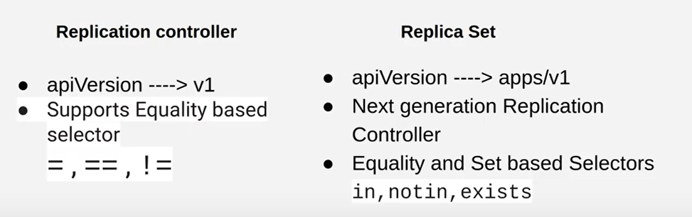

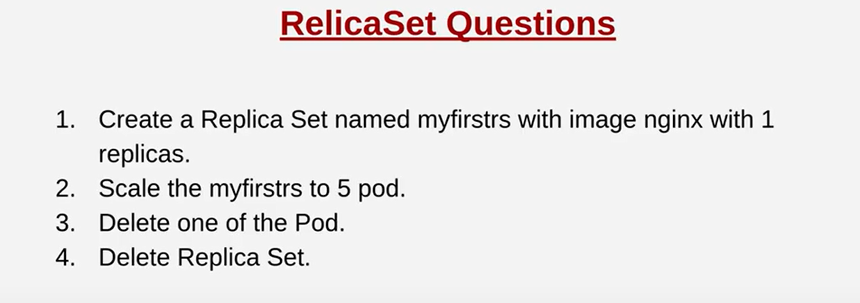

The kubectl scale command is used to immediately scale your application by adjusting the number of running containers

# Deployment set $ kubectl scale --replicas=3 deployment/demo-deployment

# ReplicaSet $ kubectl scale --replicas=3 rs/demo-replicaset

# ReplicationController $ kubectl scale --replicas=3 rc/demo-replicationcontroller

# StatefulSet $ kubectl scale --replicas=3 sts/demo-statefulset

The kubectl delete command is especially handy during clean up after the deployment of an application. During development, the creation and deployment of resources is a top concern, but the management of these resources sometimes falls to the wayside after deployment.

Kubectl delete pod podname

Note: If pod is created as a part of replica set then it must be deleted by replica set only, if you delete it manually, then replica set would be created it again.

CKA-Chapter6- Deployment: A Deployment provides declarative updates for Pods and ReplicaSets.

There is a problem with replica set:

1) If We want to upgrade from one version to another version, replica set will delete all older pods and create new pods which create application downtime.

2) Roll back strategy is not defined.

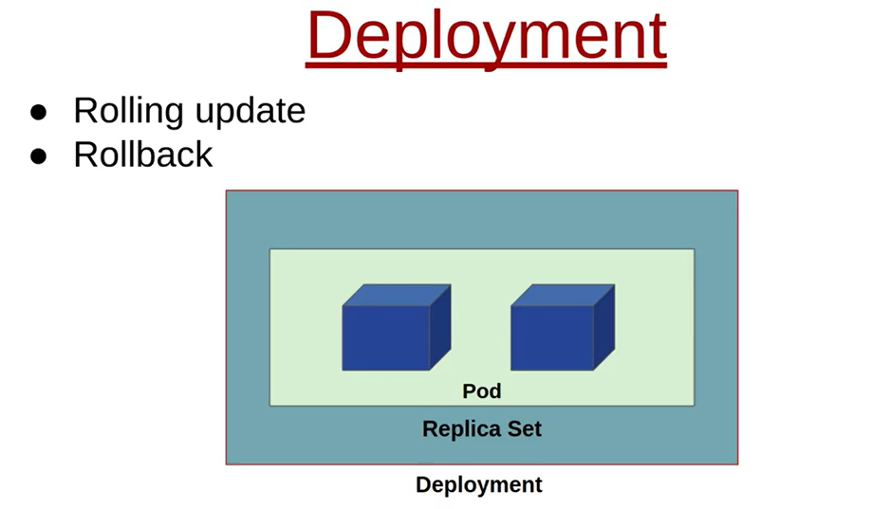

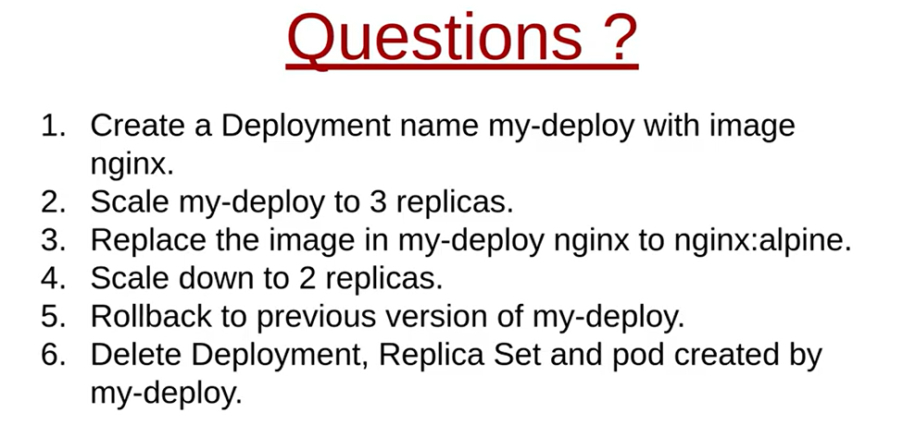

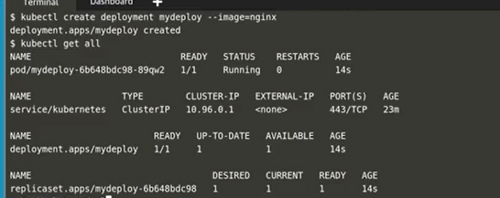

Deployment related kubectl commands

* kubectl create deployment mydeployment --image=nginx
* kubectl get pod
* kubectl get rs
* kubectl get deployment /deploy
* kubectl get all
* kubectl rollout history deploy mydeply
* kubectl rollout undo
* kubectl get deploy mydeploy -o yaml > test.yaml

CKA-Chapter7- Namespace

Namespaces are **a feature of the Linux kernel that partitions kernel resources such that one set of processes sees one set of resources while another set of processes sees a different set of resources**.

Here User-1 created blue pods, user2 created pink pods, and here no privacy.



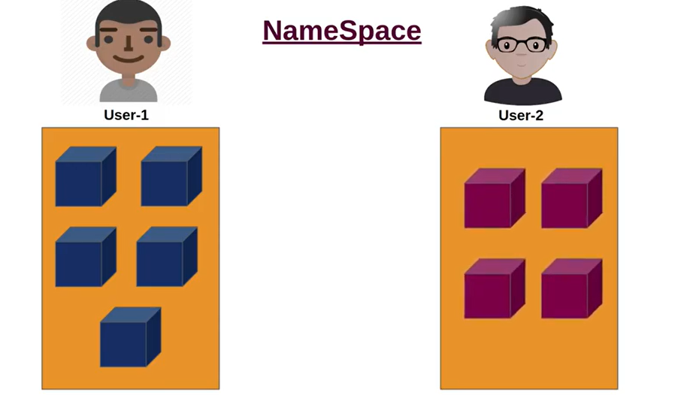









CKA-Chapter8- Request Quota

**Kubernetes defines Limits as the** **maximum amount of a resource** to be used by a container. This means that the container can never consume more than the memory amount or CPU amount indicated.

**Requests, on the other hand, are the minimum guaranteed amount of a resource** that is reserved for a container.

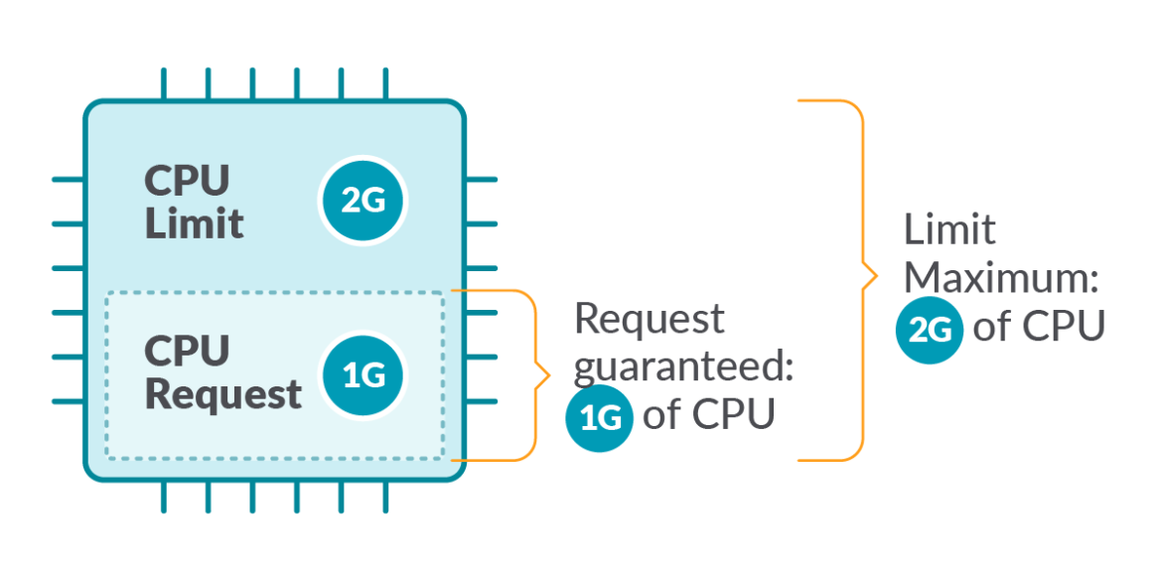

CKA-Chapter9- Services in K8s

ClusterIP, Nodeport, Headless and Ingress.

Nodeport: Samenetwork

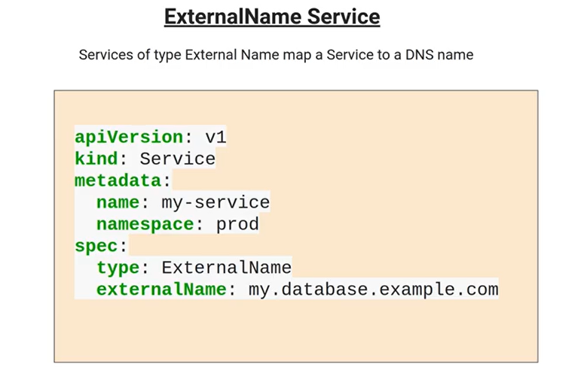

CKA-Chapter10- Exacize in services

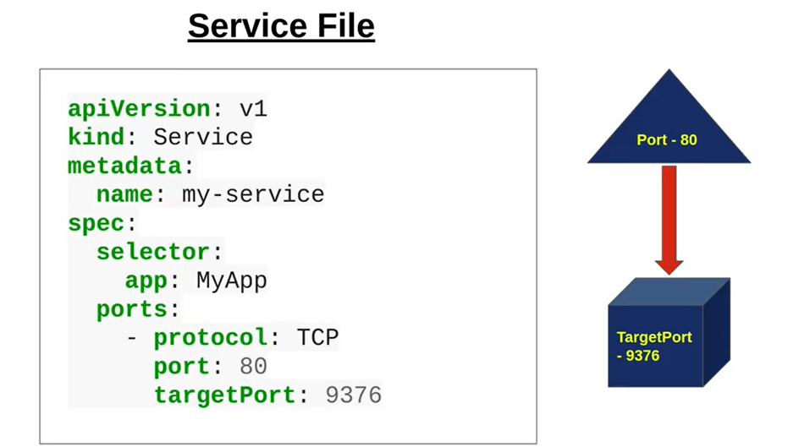

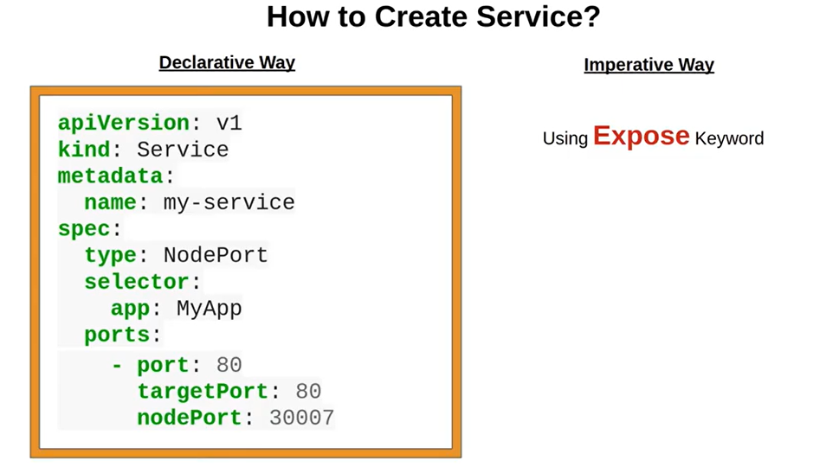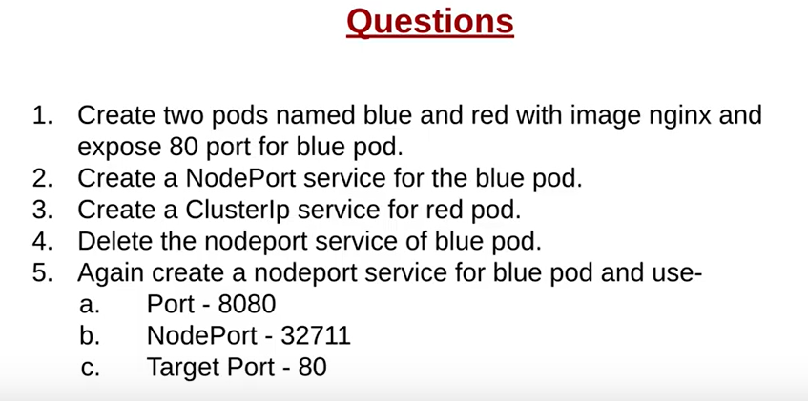

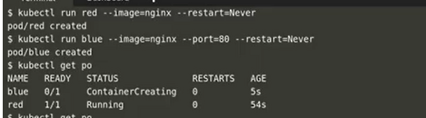

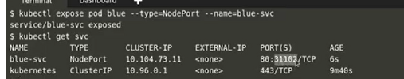

Default service is cluster ip.

nodeport: Listens for external request on all worker nodes on nodeip:nodeport and forwards the request to port.

ClusterIP: Request comes through ingress and points to service name and port.

port: Internal cluster service port for container and listens for incoming request from the nodeport and forwards to targetPort.

targetPort: Receives the request from port and forwards to container pod(port) where it's listening. Even if you don't specify this will get by default assigned the same port numbers as port.

So the traffic flows Ingress-->Service-->Endpoint(Basically has POD IP)-->POD

CKA-Chapter11- Manual scheduling

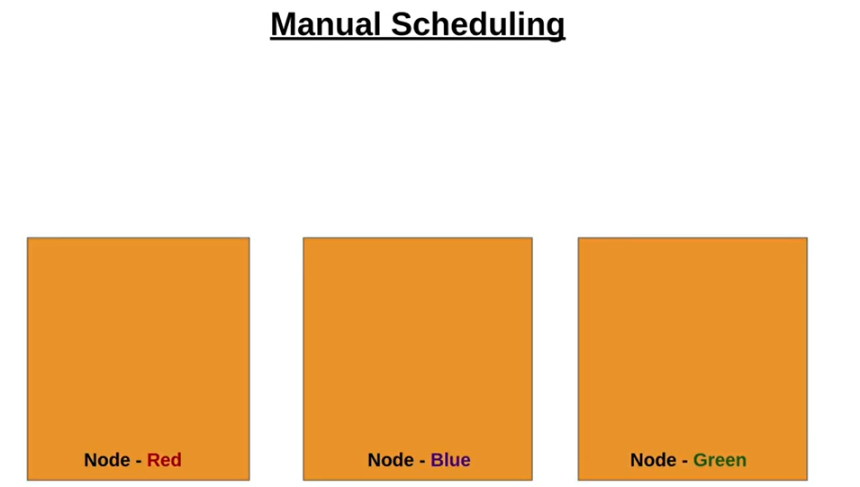

Here, when we want to create pod as per my requirement.

✳️ NodeName NodeName is the simplest form of node selection constraint, but due to its limitations, it is typically not used. nodeName is a field of PodSpec. If it is non-empty, the scheduler ignores the pod and the kubelet running on the named node tries to run the pod. Thus, if nodeName is provided in the PodSpec, it takes precedence over the above methods for node selection.

✳️ Labels and Selectors Labels are key/value pairs that are attached to objects, such as pods. Labels are intended to be used to specify identifying attributes of objects that are meaningful and relevant to users but do not directly imply semantics to the core system.

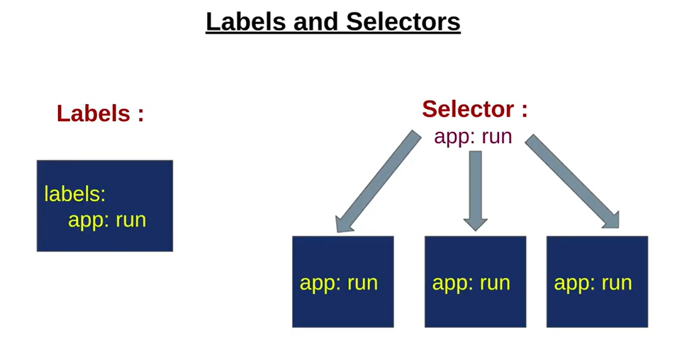

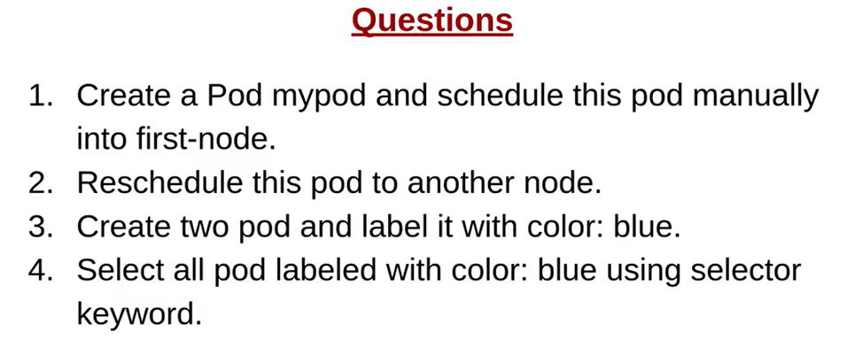

kubectl get nodes

kubectl run pod mypod --image=nginx --restart=Never --dry-run -o > pod.yaml

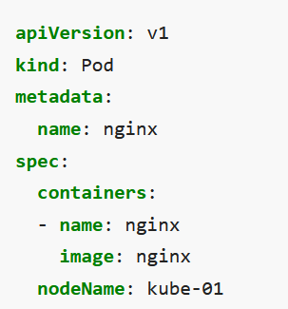

kubectl run first --image=nginx:apline -l color=blue --restart=Never

kubectl run second --image=nginx:apline -l color=green --restart=Never

kubectl get pod --selector=color=blue

CKA-Chapter12- taints and tolerant

✳️ Taints and Tolerations Taints and tolerations work together to ensure that pods are not scheduled onto inappropriate nodes. One or more taints are applied to a node; this marks that the node should not accept any pods that do not tolerate the taints.

✳️ Taint Effects

👉 NoSchedule

👉 PreferNoSchedule

👉 NoExecute

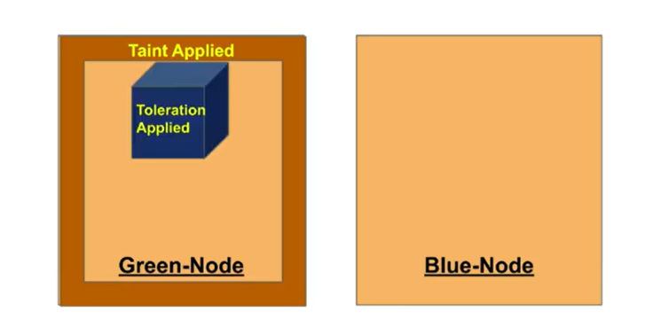

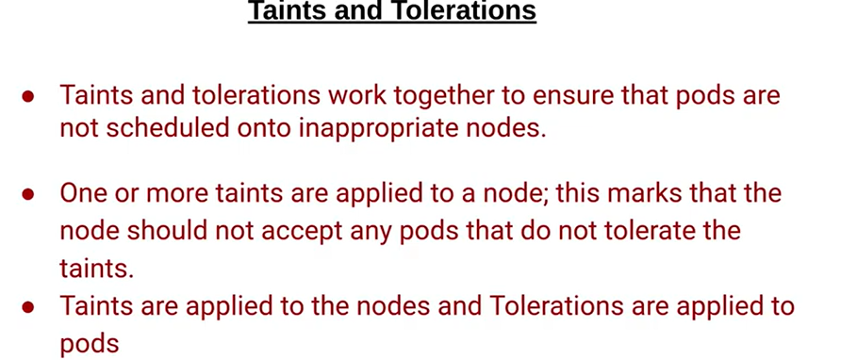

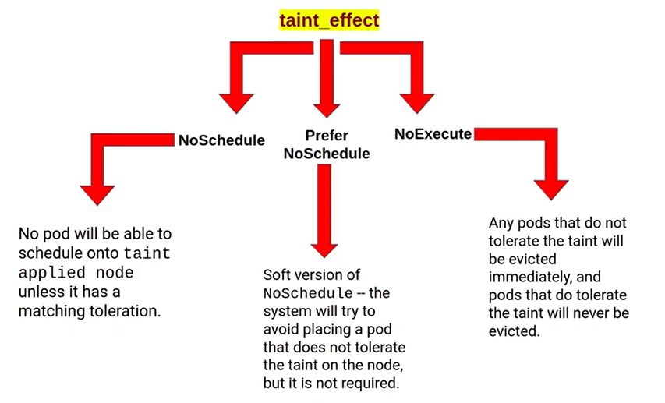

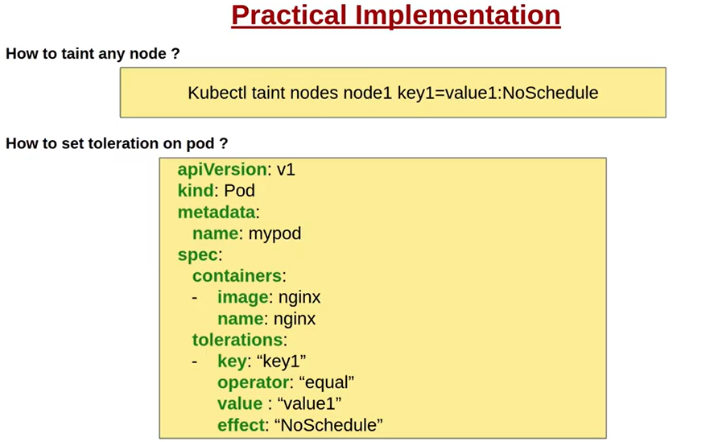

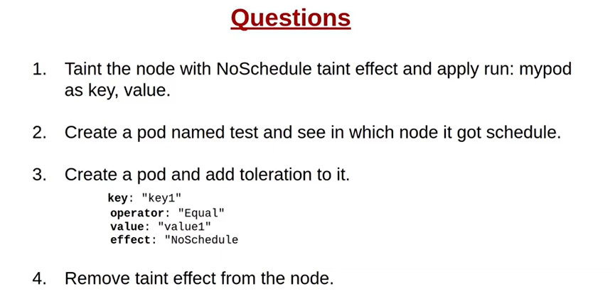

CKA-Chapter13- Nodeselector

NodeSelector NodeSelector is the simplest recommended form of node selection constraint. You can add the nodeSelector field to your Pod specification and specify the node labels you want the target node to have. Kubernetes only schedules the Pod onto nodes that have each of the labels you specify.

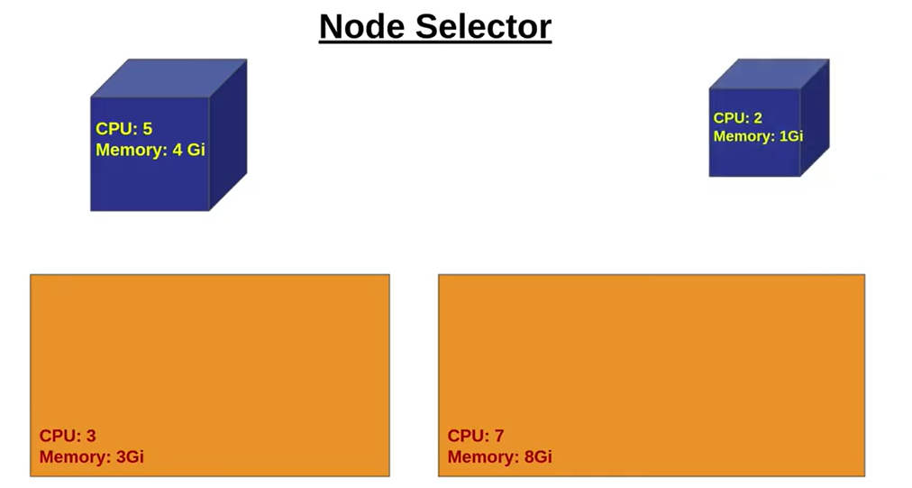

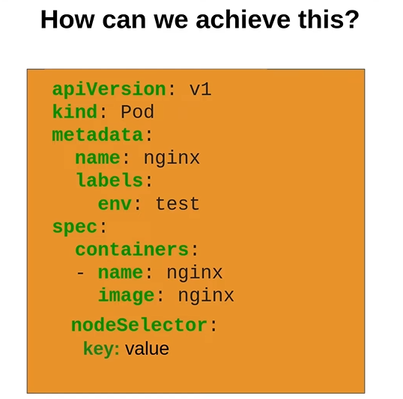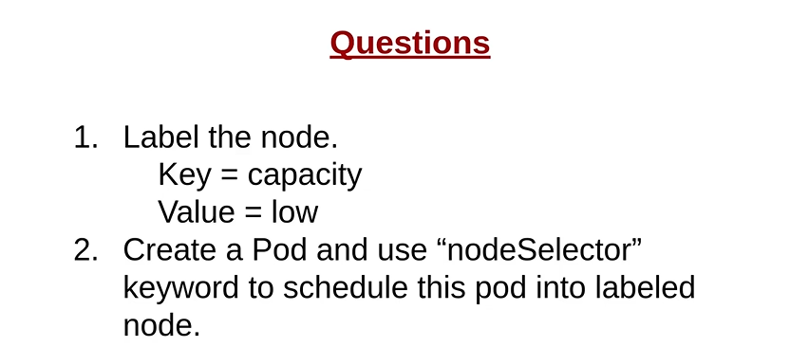

CKA-Chapter14- Daemonsets

✳️ DaemonSet A DaemonSet ensures that all (or some) Nodes run a copy of a Pod. As nodes are added to the cluster, Pods are added to them. As nodes are removed from the cluster, those Pods are garbage collected. Deleting a DaemonSet will clean up the Pods it created.

✳️ DaemonSet Uses

👉 Running a cluster storage daemon on every node

👉 Running a logs collection daemon on every node

👉 Running a node monitoring daemon on every node

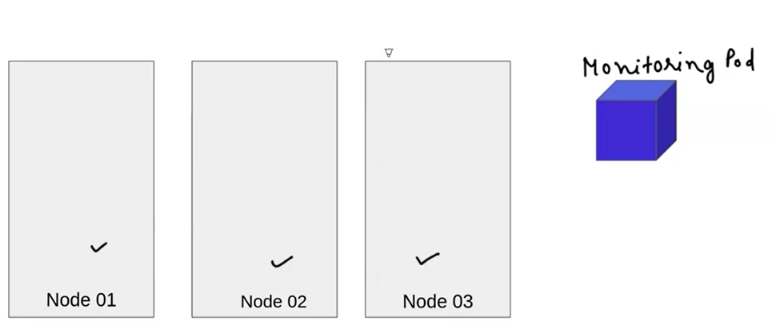

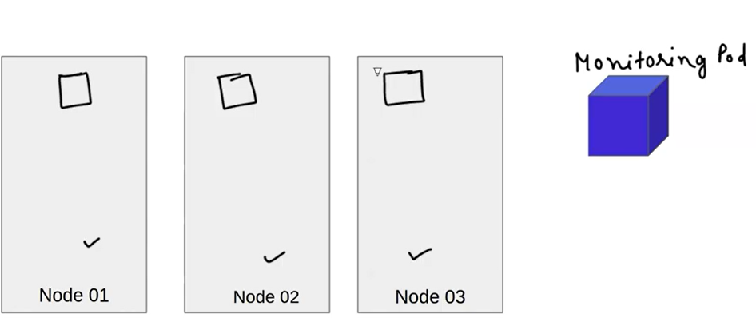

When you would be adding new node, new copy of daemon-set would be added, and when you delete node those things would be deleted.

Example of Daemon set: Kube- proxy server

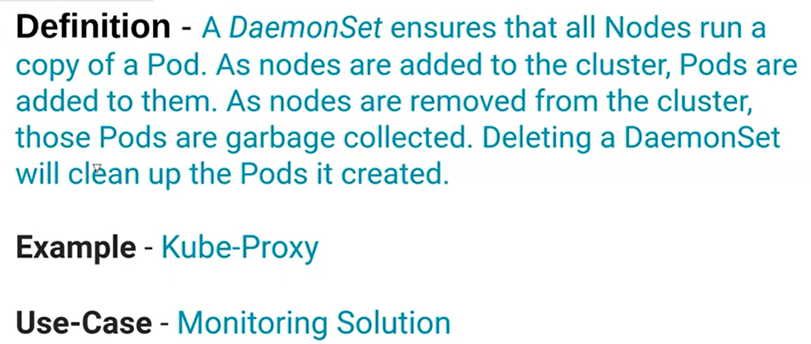

CKA-Chapter15- Static pod

Static Pods Static Pods are managed directly by the kubelet daemon on a specific node, without the API server observing them. Unlike Pods that are managed by the control plane instead, the kubelet watches each static Pod. Static Pods are always bound to one Kubelet on a specific node

How to create pod.



How to create static pod <https://kubernetes.io/docs/tasks/configure-pod-container/static-pod/>

Step1) Choose a node.

Step2) Choose a directory, say /etc/kubernetes/manifests and place a web server Pod definition there, for example /etc/kubernetes/manifests/static-web.yaml

Sep3) Restart kubelet.

Example of static pod: Control plane component.

Chapter 16: multiple schedular

Scheduling Strategy

Let’s understand this concept by imagining a scenario. We have a user named Jack and he wants a pod with x number of CPU and x number of memory to run the application smoothly. He runs the kubectl command to create the pod. This request will first go to the kube-apiserver, and the kube-apiserver will first check the pod’s resource and all other requirements and then will create a pod for him. The pod will be in the pending state due to no node assigned to it yet.

Now, Kube-scheduler comes into the picture and looks for the newly created pods that are unscheduled yet. As soon as it gets a pod, first of all, it starts selecting the right node for it considering its resource requirements and other requirements in 2 steps.

Step 1:- Filtering the nodes

In this step, Kube-scheduler first filters out all the nodes that are suitable according to the pod’s requirements and makes a list. If the list is empty it means that no node is capable of scheduling that pod and in such condition, the pod remains in a pending and unscheduled state. But if the list is not empty it means there are some nodes available that are capable enough to schedule the pods.

Step 2:- Scoring the nodes

In this step, Kube-scheduler assigns a score to each node present in the list to choose the most suitable node for the pod and the pod gets scheduled in the node with the highest score. If there is more than one node with equal scores, Kube-scheduler selects one of these at random.

Custom Scheduler

We know that Kubernetes comes with kube-scheduler as a default scheduler. But if the default scheduler does not suit our needs we can implement our own scheduler and can  
even run multiple schedulers simultaneously alongside the default scheduler and instruct Kubernetes what scheduler to use for each of our pods. Let’s learn how to implement a custom scheduler in Kubernetes.

As we know, if we set up a Kubernetes cluster with the kubeadm tool then all the control plane components are run as a static pod and their YAML files are stored at /etc/kubernetes/manifests/ path.  
To implement a custom scheduler we have two options –  
We can download the Kube-scheduler binary.  
We can use the same static pod YAML file to create a custom scheduler.  
In this article, we will implement our custom scheduler with the second option.

Steps to Implement Custom Scheduler

Below 10 steps will help you to create a custom scheduler as a pod and to use that scheduler to schedule an Nginx pod. Let’s copy the Kube-scheduler.yaml located under the /etc/kubernetes/manifests/ directory to my-scheduler.yaml file outside the /etc/kubernetes/manifests/ directory and update the my-scheduler.yaml file as mentioned in the below steps.

1. Change the name under the labels section to my-scheduler and we will create this pod under the default namespace.

|  |  |
| --- | --- |
|  | apiVersion: v1 |
|  | kind: Pod |
|  | metadata: |
|  | labels: |
|  | component: my-scheduler |
|  | tier: control-plane |
|  | name: my-scheduler |

2. Under command field update –leader-elect=true to –leader-elect=false. Because we only have a single master node in our cluster. If we had multiple master nodes, we would choose –leader-elect=true.

|  |  |
| --- | --- |
|  | spec: |
|  | containers: |
|  | - command: |
|  | - kube-scheduler |
|  | - --authentication-kubeconfig=/etc/kubernetes/scheduler.conf |
|  | - --authorization-kubeconfig=/etc/kubernetes/scheduler.conf |
|  | - --bind-address=127.0.0.1 |
|  | - --kubeconfig=/etc/kubernetes/scheduler.conf |
|  | - --leader-elect=false |

3. For our custom scheduler we have to find an available port to bind to the pod. In my case, no service is running on the 10282 port. You can check the free port number by running the below command.

netstat -natulp | grep 10282

4. Now set –scheduler-name property and assign the name you want to give to your custom scheduler. I am using my-scheduler as a name so it will look like –

|  |  |
| --- | --- |
|  | - --port=10282 |
|  | - --scheduler-name=my-scheduler |
|  | - --secure-port=0 |

5. Leave other things as it is and change the port number in the livenessProbe section.  
port: 10282.

|  |  |
| --- | --- |
|  | livenessProbe: |
|  | failureThreshold: 8 |
|  | httpGet: |
|  | host: 127.0.0.1 |
|  | path: /healthz |
|  | port: 10282 |

6. The final YAML file will look like the below code.

|  |  |
| --- | --- |
|  | apiVersion: v1 |
|  | kind: Pod |
|  | metadata: |
|  | labels: |
|  | component: my-scheduler |
|  | tier: control-plane |
|  | name: my-scheduler |
|  | spec: |
|  | containers: |
|  | - command: |
|  | - kube-scheduler |
|  | - --authentication-kubeconfig=/etc/kubernetes/scheduler.conf |
|  | - --authorization-kubeconfig=/etc/kubernetes/scheduler.conf |
|  | - --bind-address=127.0.0.1 |
|  | - --kubeconfig=/etc/kubernetes/scheduler.conf |
|  | - --leader-elect=false |
|  | - --port=10282 |
|  | - --scheduler-name=my-scheduler |
|  | - --secure-port=0 |
|  | image: k8s.gcr.io/kube-scheduler:v1.19.0 |
|  | imagePullPolicy: IfNotPresent |
|  | livenessProbe: |
|  | failureThreshold: 8 |
|  | httpGet: |
|  | host: 127.0.0.1 |
|  | path: /healthz |
|  | port: 10282 |
|  | scheme: HTTP |
|  | initialDelaySeconds: 10 |
|  | periodSeconds: 10 |
|  | timeoutSeconds: 15 |
|  | name: kube-scheduler |
|  | resources: |
|  | requests: |
|  | cpu: 100m |
|  | startupProbe: |
|  | failureThreshold: 24 |
|  | httpGet: |
|  | host: 127.0.0.1 |
|  | path: /healthz |
|  | port: 10282 |
|  | scheme: HTTP |
|  | initialDelaySeconds: 10 |
|  | periodSeconds: 10 |
|  | timeoutSeconds: 15 |
|  | volumeMounts: |
|  | - mountPath: /etc/kubernetes/scheduler.conf |
|  | name: kubeconfig |
|  | readOnly: true |
|  | hostNetwork: true |
|  | priorityClassName: system-node-critical |
|  | volumes: |
|  | - hostPath: |
|  | path: /etc/kubernetes/scheduler.conf |
|  | type: FileOrCreate |
|  | name: kubeconfig |
|  | status: {} |

7. Now, save the my-scheduler.yaml file and run the below command to create the pod.

kubectl create -f my-scheduler.yaml

8. It will create a custom scheduler pod in the default namespace. You can check via the command below.

9. Let’s create a pod YAML file and instruct Kubernetes to use my-scheduler as a scheduler for this pod by using the schedulerName option in the file. YAML file will look like this –

|  |  |
| --- | --- |
|  | apiVersion: v1 |
|  | kind: Pod |
|  | metadata: |
|  | name: mypod |
|  | labels: |
|  | name: multischeduler |
|  | spec: |
|  | schedulerName: my-scheduler |
|  | containers: |
|  | - name: nginx |
|  | image: nginx |

10. Now, we can check whether my-scheduler as a scheduler is used or not by looking into the event section of this pod. Use the below command and check the events of this pod.

Who assign pod to node? > Kube-schedular

Multiple Schedulers Kubernetes ships with a default scheduler that is Kube-Scheduler. If the default scheduler does not suit your needs, you can implement your own scheduler. Moreover, you can even run multiple schedulers simultaneously alongside the default scheduler and instruct Kubernetes what scheduler to use for each of your pods. Let's learn how to run multiple schedulers in Kubernetes.



How to select node?



A) Filter out the nodes.



B) Rank the node.



Random selection: if two nodes have same configuration.



How we can create custom schedular? > with the help of **static pod.**

Case study of multiple schedular >

Chapter 17: Rolling deployment

Meet **harry**, he is a DevOps engineer and works in an ABC private limited and his boss has given him the task of deploying the **Nginx** web server which is a basic requirement of the software on which the company is working. He ran the below command to deploy the Nginx server whose configuration is written in the **nginx-deployment.yaml**file.

kubectl apply -f nginx-deployment.yaml --record=true

|  |  |
| --- | --- |
|  | apiVersion: apps/v1 |
|  | kind: Deployment |
|  | metadata: |
|  | name: nginx-deployment |
|  | labels: |
|  | run: nginx |
|  | spec: |
|  | replicas: 3 |
|  | selector: |
|  | matchLabels: |
|  | run: nginx |
|  | template: |
|  | metadata: |
|  | labels: |
|  | run: nginx |
|  | spec: |
|  | containers: |
|  | - name: nginx |
|  | image: nginx:1.14.2 |
|  | ports: |
|  | - containerPort: 80 |

By running the above command, A deployment has been created with the name nginx-deployment, image **nginx:1.14.2**, and with 3 replicas. We can check the same by running –

kubectl get deployment

The output will be similar to the this –

NAME READY UP-TO-DATE AVAILABLE AGE

nginx-deployment 3/3 3 3 1s

So this is how Harry successfully created his first deployment.

After some time, Harry was asked to upgrade the image of the same deployment from nginx:1.14.2 to **nginx:1.16.1**. By using the below command, he updated the deployment’s image.

kubectl set image deployment/nginx-deployment nginx=nginx:1.16.1 --record=true

The output is similar to:-

deployment.apps/nginx-deployment image updated

To see the rollout status, run:-

kubectl rollout status deployment/nginx-deployment

After some time again he was asked to upgrade the image from image nginx:1.16.1 to **nginx:1.21.6**.

kubectl set image deployment/nginx-deployment nginx=nginx:1.21.6 --record=true

As soon as the image was updated, the software stopped running due to the incompatibility of the software with the image nginx=nginx:1.21.6 and no one was able to access that software. Harry got a little scared and wondered what could happen so that he could get back the software running with the previous image.

Then after a lot of research, he came to know about the **rolling back in deployment**, and by using that approach he solved his problem. Let’s see what is the rolling back in deployment and how it works.

Whenever we make changes in the created deployment, the **rollout is triggered** and assigns a number to that change, that number is called the **revision** number.

**Note –** The rollout is triggered whenever the deployment is updated but only if the Deployment’s pod template (that is, .spec.template) is changed, for example, if the labels or container images of the template are updated. Other updates, such as scaling the Deployment, do not trigger a rollout.

So that means the rollout started when Harry updated the image, and that change got assigned a revision number.

To check the revisions of this Deployment:

kubectl rollout history deployment/nginx-deployment

The output is similar to this:-

deployments "nginx-deployment"

REVISION CHANGE-CAUSE

1 kubectl apply -f nginx-deployment.yaml --record=true

2 kubectl set image deployment/nginx-deployment nginx=nginx:1.16.1 --record=true

3 kubectl set image deployment/nginx-deployment nginx=nginx:1.21.6 --record=true

These revision numbers represent the versions of a deployment. To see the details of each revision, run:

kubectl rollout history deployment/nginx-deployment --revision=2

**Rolling Back to Previous Revision**

Harry has decided to undo the current rollout and rollback to the previous stable revision:

kubectl rollout undo deployment/nginx-deployment

By running the above command,  he has reached the last deployment version running nginx:1.16.1 image. But what if he wanted to rollback directly from nginx:1.21.6 to nginx:1.14.2? This is called rollback to a specific revision number, this can be achieved by specifying –to-revision: with the below command –

kubectl rollout undo deployment/nginx-deployment --to-revision=1

The output is similar to this:-

deployment.apps/nginx-deployment rolled back

The Deployment is now rolled back to a previous stable revision. We can see this by describing the deployment –

kubectl describe deployment nginx-deployment

This is how Harry went back in time and run his compatible nginx:1.16.1 server by using the concept of rolling back in deployment. This magical concept is known as **Rollback In Deployment**.

Chapter 18: Command and argument





Downward API kubernetes

The downward API allows containers to consume information about themselves or the cluster without using the Kubernetes client or API server.

Chapter19: Set and update variable of docker image

Let’s consider below docker file

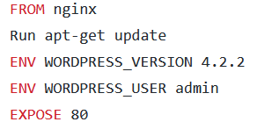

When we build docker image these environment variable would be created, we can override these variable in pod yaml.

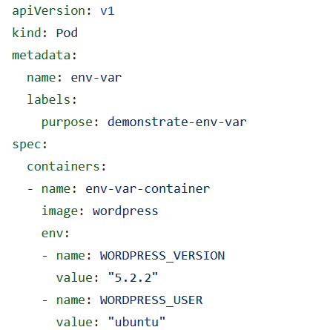

In order to validate:

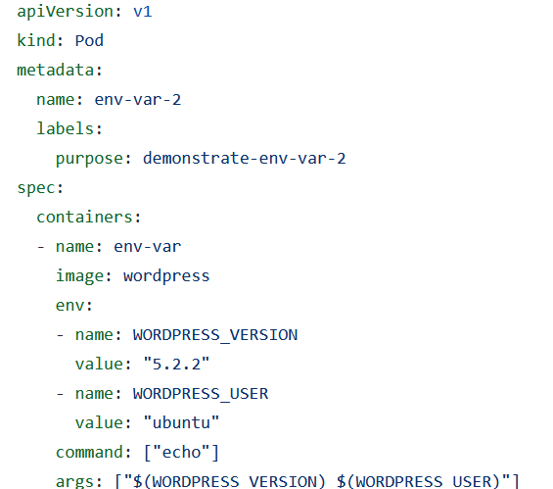

**To Build Docker image** docker build -t wordpress .

**To apply yaml files** kubectl apply -f <file-name>

**To see pods** kubectl get pods

**To check logs of a pod** kubectl logs <pod-name>

**To print environment variables of a pod** kubectl exec <pod-name> -- printenv

Chapter20: Fieldref and Resourcefieldref

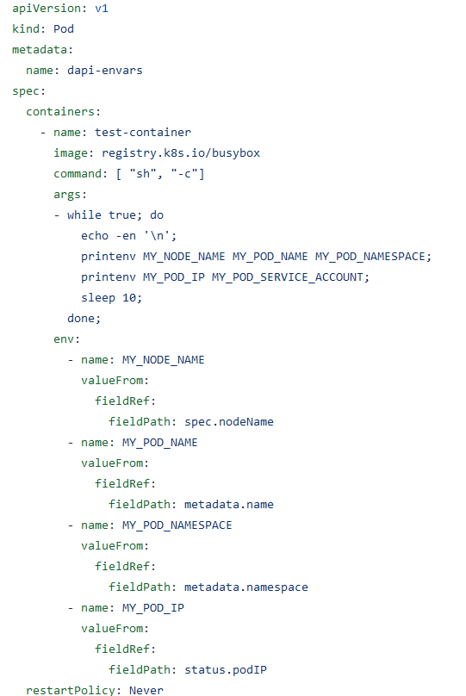

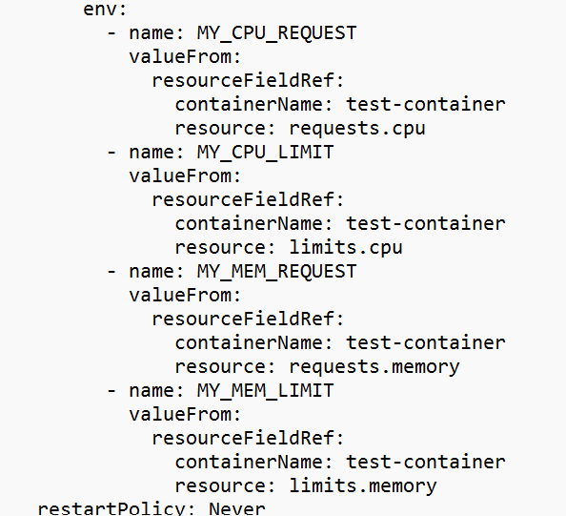

Chapter21 Exposing variable by volume

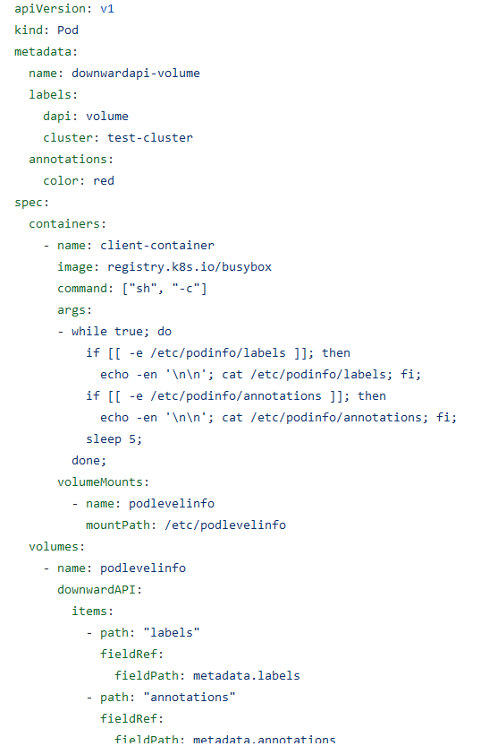

Chapter 22: Config map

